Caroline Humphrey - Buryatia photos - No. 3-06

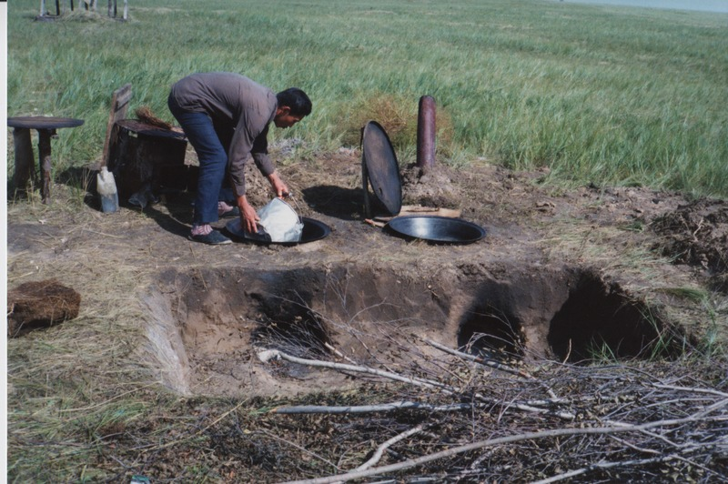

### identifier

2b9d58bd-7ef0-4021-94e0-8bf208989d3f

### creator

Humphrey, Caroline

### type

Image

### coverage

Khargant

### description

Outdoor cooking stove.

### publisher

### source

Scanned from a print held in the archives of the Mongolia and Inner Asia Studies Unit, University of Cambridge.

### rights

### subject

### date

1993

### language

### contributor

### original filename

Humphrey-Buryatia-photos-3-06.png

### relation

### extent

3.9MiB

1799x1196 px

### format

image/png