Mongolia, Video Footage from the National Archives

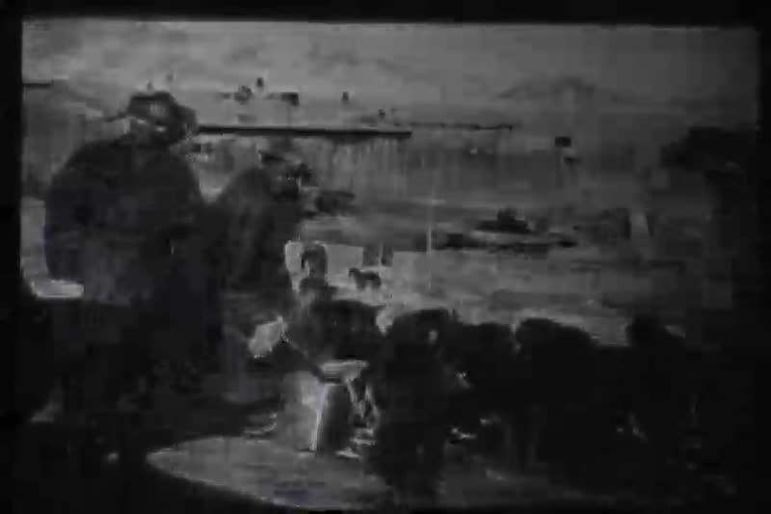

### identifier

2c17361b-cd75-4c71-aec5-21905abb1474

### creator

Penn Museum

### type

Moving Image

### coverage

Mongolia

Mongolian Museum of National History

Ulaanbaatar

### description

Archival video footage related to Mongolia’s political history. Feb. 18, 1990.

[4:25] "Hunger Strike, March 7th- demand multiparty system".

[12:18] Leader of Woman Organization.

[12:50] Chimid.

[14:46] Lamas blessing hunger strikers.

[16:24] Gonchigdorj.

[16:58] "1959 Herder propaganda film, working collective meeting in countryside".

[20:23] 1967 Propaganda film, collective.

[23:00] U.B 1921- Buddhist Ceremony (cool).

[25:00] Old market.

[26:00] 1980 U.B. from the air.

[27:00] U.B. 1920.

[29:00] Lamas Teach.

[30:00] 1990 Writing Constitution- Chimid, Zorig.

[31:00 Voting.

[32:00] 1st Pres. of Democratic Mongolia: Ochirbat.

[33:00 Ochirbat accepting/showing Constitution.

[34:00 "Constitution" -- Birth of Mongol Democracy.

[34:00] 1921 Mongolia/ Russia Friendship Agreement. Nov. 5, 1921. Mongolia becomes communist.

[39:00 1990 James Baker visits.

[45:00] June 1990 1st vote for Mongol People.

### publisher

University of Pennsylvania Museum of Archaeology and Anthropology Films

### source

<https://archive.org/details/UPMAA_films>

### rights

All rights are reserved by the University of Pennsylvania Museum of Archaeology and Anthropology (Penn Museum). Any use of the footage in productions is forbidden unless rights have been secured by contacting the Penn Museum Archives at 215-898-8304, or email photos@pennmuseum.org. This film and all of the films in the Penn Museum collection are copyrighted by the Penn Museum, and are not in the public domain.

### subject

### date

2011-07-13 09:40:39

### language

Mongolian

### original filename

V-450-35.mov

### extent

99.0 MiB

2702.268333

### format

video/quicktime

### modified

2017-05-25 07:14:58

### remote embed url

https://archive.org/embed/V-450-35

### public

FALSE