Caroline Humphrey Mongolia Super8 film no. 17

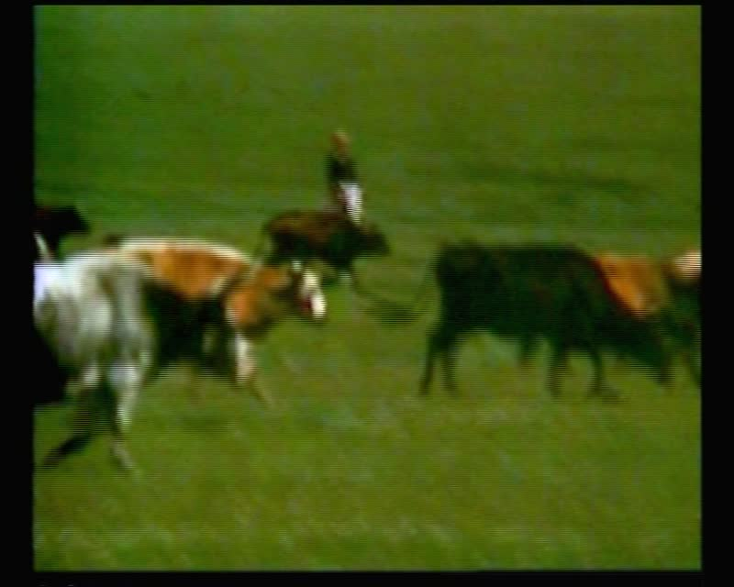

### identifier

2dd0da0a-3f0c-4dae-87ec-3f5a7e37b898

### creator

Humphrey, Caroline

### type

Moving Image

### coverage

Arkhangai aimag

Mongolia

### description

Tsetserleg (Arkhangai aimag). View of the monument and road into town; boy herding cattle; the river; yaks; old man on horse; ovoo.

### publisher

MIASU

### source

Digitized from a VCR transfer tape held at the Mongolia and Inner Asia Studies Unit, University of Cambridge

### rights

Copyright Caroline Humphrey

### subject

aimag centres

### date

ca. 1970s

### language

None

### original filename

humphrey-super8-mongolia-17.mp4

### extent

905.6 MiB

217.430000

### format

video/mp4

### modified

2017-06-16 11:04:49

### alternate url

https://archive.org/embed/2dd0da0a-3f0c-4dae-87ec-3f5a7e37b898