Feeding pigs and a newborn foal

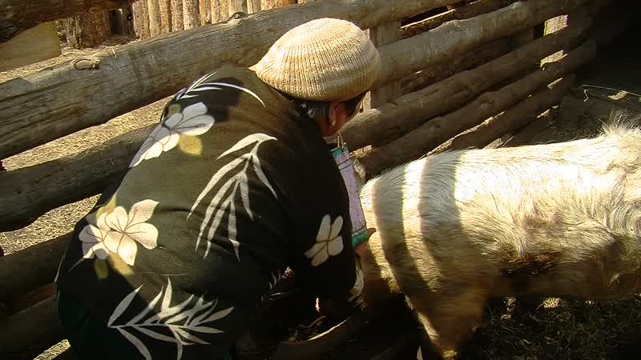

### identifier

2ed6b605-ad1d-41c7-afde-c71fd6264099

### creator

Thrift, Eric

### type

Moving Image

### coverage

Mongolia

Selenge aimag

Yeröö sum

### description

These two short clips were taken at Tasag in Yeröö. In the first clip, Gerlee and her son Nyamdorj feed their pigs, as Sookoo looks on. The second clip shows Bat-Erdene's newborn foal.

### publisher

### source

### rights

### subject

Pastoralism Videos

Feeding Pigs

Newborn Foal

Gerlee-Nyamdorj

### date

2012-04-17

### language

### format

inode/directory

### modified

2018-03-01 15:57:14

### original filename

PastoralismVideos--2012-04-17--FeedingPigs--NewbornFoal--Gerlee-Nyamdorj--Selenge-Yeroo.vclips

### table of contents

|  |  |  |
| --- | --- | --- |
| time | clip | description |
| 0:00:00 | 244 0276 01 | Gerlee and her son Nyamdorj feed their pigs. |
| 0:08:49 | 244 0277 01 | Bat-Erdene's newborn foal |