4020

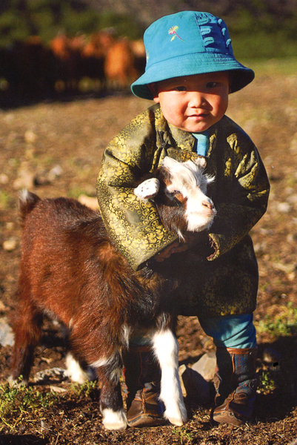

### identifier

302d7655-6562-45dd-a9be-05131fb972ab

### creator

Oktyabri, D.

### type

Image

### coverage

Mongolia

### description

Herder girl

### publisher

### source

https://ich.unesco.org/img/photo/src/4020.jpg

### rights

### subject

### date

2010

### language

### original filename

04020.jpg

### extent

2.0 MiB

1409x2108 px

### format

image/jpeg

### modified

2012-12-05 02:28:26