Caroline Humphrey - Buryatia photos - No. 21

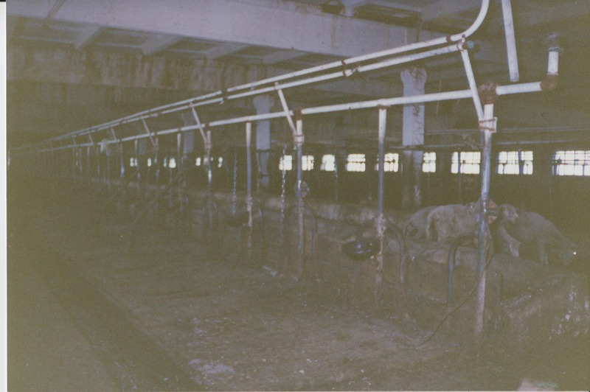

### identifier

3213676f-b2de-4327-9353-7b1016973f4d

### creator

Humphrey, Caroline

### type

Image

### coverage

Ulung Collective

Buryatia

USSR

### description

Inside the cattle wintering shed (milking cows only).

### publisher

### source

Scanned from a print held in the archives of the Mongolia and Inner Asia Studies Unit, University of Cambridge.

### rights

### subject

### date

1993-07-25

### language

### contributor

### original filename

Humphrey-Buryatia-photos-21.png

### relation

### extent

3.5MiB

1799x1196 px

### format

image/png