Photographs of Dashbalbar sum, No. 42

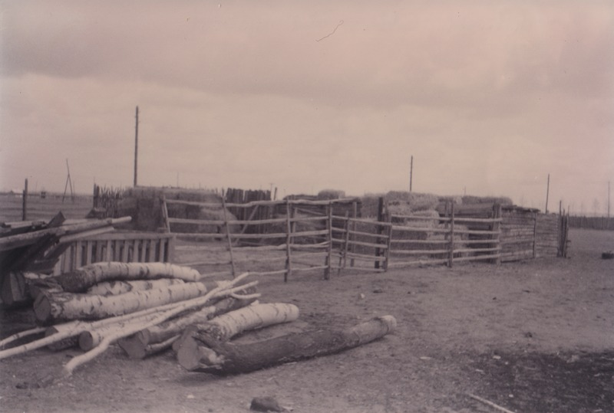

### identifier

32740b82-a0bf-4203-8aa6-83089cec5287

### creator

Batbuyan B.

### type

Image

### coverage

Dashbalbar sum

Dornod aimag

Mongolia

### description

Stores of firewood and fodder

### publisher

### source

Scanned from a photographic print held in the archives of the Mongolia and Inner Asia Studies Unit, University of Cambridge.

### rights

### subject

fodder

fuel

### date

ca. 1993

### language

### format

image/png

### contributor

### original filename

bair-batbuyan-photos-42.png

### relation

### extent

1754x1181 px

2.7 MiB