Photograph from Govisumber, No. 03

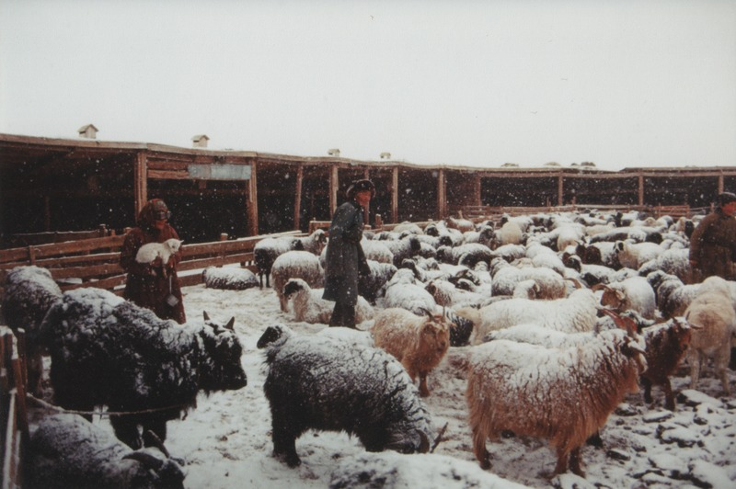

### identifier

32d3f16e-d3ff-4fcb-9d1e-779e47ed0c7b

### creator

Sneath, David

### type

Image

### coverage

Govisumber aimag

Mongolia

### description

### publisher

### source

scanned from a photographic print held in the archives of the Mongolia and Inner Asia Studies Unit, University of Cambridge

### rights

### subject

livestock enclosures

morning activities

pastoral camps

### date

1995

### language

### format

image/png

### contributor

### original filename

sneath-govisumber_03.png

### relation

### extent

1776x1182 px

3.2MiB