Photographs from Barguzin, No. 03

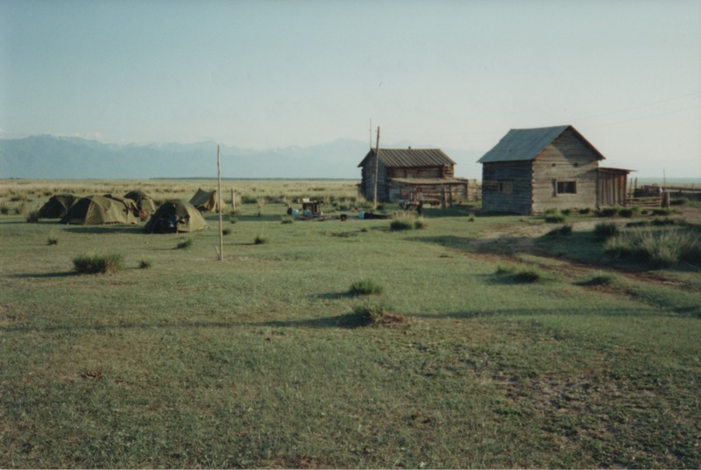

### identifier

33e95a4f-6c1a-4d4c-8ea6-eb10e77ea5c8

### creator

Gomboev, Bair

### type

Image

### coverage

Barguzin

Burtyatia

Russian Federation

### description

Summer camp, Argada, in West part of district. The post productive pastures of the district.

### date

1993-07

### language

### format

image/png

### modified

2017-05-25 09:58:02

### original filename

bair-batbuyan-photos-03.png

### source

Scanned from a photographic print held in the archives of the Mongolia and Inner Asia Studies Unit, University of Cambridge

### extent

2.9 MiB

1777x1191 px

### subject

pastoral camps

rangeland