North Asian Borders Network website

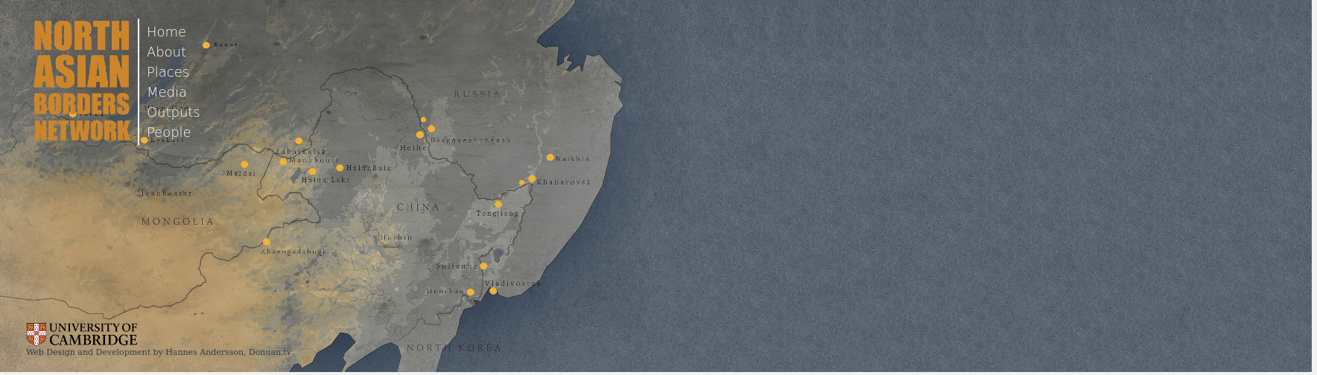

### identifier

348c49eb-bee8-44d5-8ed8-e02b96c420f2

### creator

MIASU

### type

Text

### coverage

Russia

China

### description

The North Asian Borders Network, an international and multidisciplinary research network specialising in the strategic border area of Russia, China and Mongolia, was established in 2010 at the University of Cambridge by Professor Caroline Humphrey.

The project “Where Rising Powers meet: China and Russia at their North Asian Border,” funded by the Economic and Social Research Council (U.K.) ran between 2012 and 2015. The specific aim of the project has been to investigate the differing political economies of the two countries and their trajectories in the post-1991 era. With each state exercising full sovereignty right up to their border, there is no better place to compare the two remarkably dissimilar ways that economic development, the rule of law, citizen rights, migration, and inequality are managed. The region is also home to many ethnic groups who straddle the border, such as the Mongols, Buryats, Evenks and Koreans. When the border reopened in the early 1990s, these groups were able to re-establish old connections as well as open new links, processes which the project explores.

### publisher

### source

<http://www.northasianborders.net>

### rights

### subject

hybridity

frontiers

### date

2017-05-25 10:51:49

### language

### original filename

north-asian-borders-website.url

### extent

34.0 B

### format

text/plain

### modified

2017-05-25 08:44:16