Mongolia, R. Burmaa interview, NGO/women's org

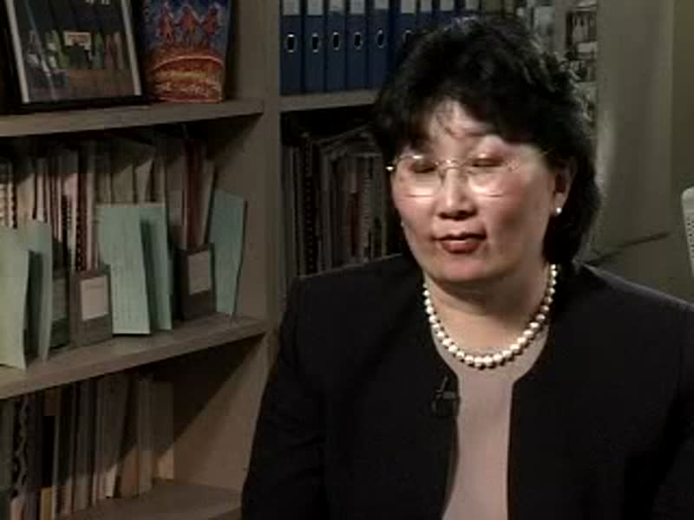

### identifier

367c1fbc-c7f1-45d6-b271-7ec7092e3306

### creator

Penn Museum

### type

Moving Image

### coverage

Mongolia

Ulaanbaatar

### description

Interview with Burmaa - NGO/Woman's Organization. B.Roll.

### publisher

University of Pennsylvania Museum of Archaeology and Anthropology Films

### source

<https://archive.org/details/UPMAA_films>

### rights

All rights are reserved by the University of Pennsylvania Museum of Archaeology and Anthropology (Penn Museum). Any use of the footage in productions is forbidden unless rights have been secured by contacting the Penn Museum Archives at 215-898-8304, or email photos@pennmuseum.org. This film and all of the films in the Penn Museum collection are copyrighted by the Penn Museum, and are not in the public domain.

### subject

### date

2009-01-08 13:42:11

### language

Mongolian

### original filename

V-450-09.mp4

### extent

222.1 MiB

3401.801802

### format

video/mp4

### modified

2017-05-25 07:14:58

### remote embed url

https://archive.org/embed/V-450-09

### public

FALSE