2475372. Pilgrimage to Bogdo Uul, 2017

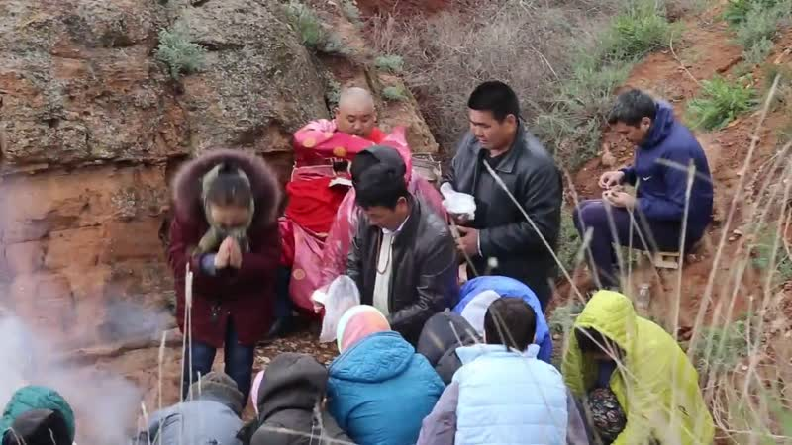

### identifier

36c4db54-940d-49bf-9e84-8b344b0c5f08

### creator

Kalmyk Cultural Heritage Documentation Project

### type

Moving Image

### coverage

Kalmykia

Russia

### description

### publisher

University of Cambridge

### source

<http://www.kalmykheritage.socanth.cam.ac.uk>

### rights

Copyright Kalmyk Cultural Heritage Documentation Project. Licensed under a Creative Commons BY-NC-ND Unported license.

### subject

Buddhism

Kalmyks

### date

2017-05-08 08:52:34

### language

### extent

1.1 GiB

2982.600000

### format

video/mp4

### modified

2017-05-08 00:52:34

### original filename

2475381.mp4

### remote embed url

http://sms.cam.ac.uk/media/2475372/embed

### public

FALSE