Oral history interview No. 081218A with Davaasambuu (b. 1958): translation

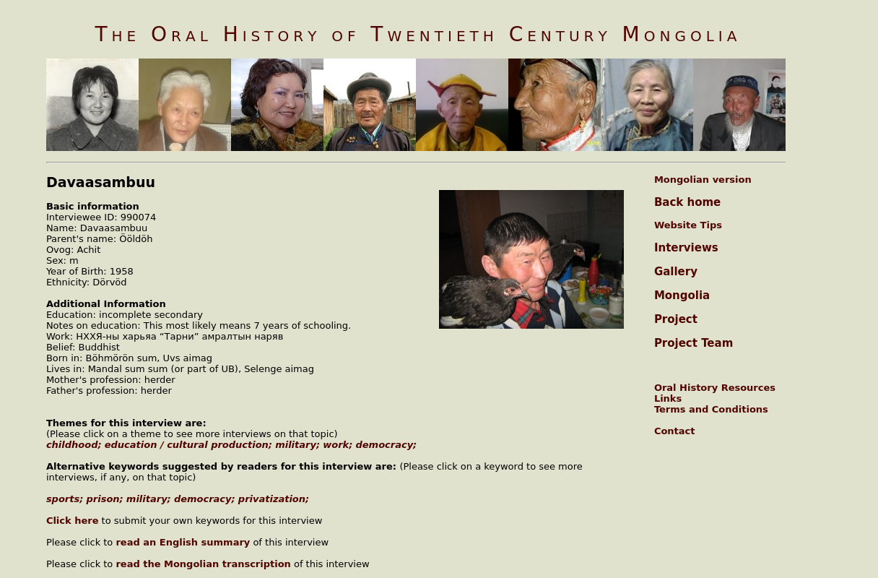

### identifier

380e0214-f49d-4aa5-a196-4b3910cef8a7

### creator

Davaasambuu

### type

Text

### coverage

Mongolia

Selenge aimag

### description

Oral history interview with Ööldöh Davaasambuu

### publisher

Oral History of Twentieth Century Mongolia

### source

<http://amantuuh.socanth.cam.ac.uk/search/view_trans.php?Interview=081218A>

### rights

Copyright MIASU. Reproduced with permission. Brief excerpts from interviews and other material may be used in academic or popular work for non-commercial purposes provided proper attribution and credit is given to the Oral History of Twentieth Century Mongolia and the Mongolia and Inner Asia Studies Unit (MIASU). You must not: (a) republish this material (including republication on another website) without the express written permission of MIASU; (b) sell, rent or sub-license material from the website; (c) show any material from the website in public without attribution to The Oral History of Twentieth Century Mongolia; (d) reproduce, duplicate, copy or otherwise exploit material on the website for a commercial purpose without express written permission; (e) use the material in any way that is damaging to the project or any of the persons named in the interviews. See <http://amantuuh.socanth.cam.ac.uk/terms.php> for details.

### subject

democracy

military

oral history

prison

privatization

sports

### date

2008

### language

English

### format

text/plain

### contributor

Khishigsüren

### original filename

081218A-Davaasambuu-translation.url

### relation

8b90d47b-8dff-48b7-94cd-dd6cf494bdcd

### extent

74.0 B