State Formation and Periodization in Inner Asian History

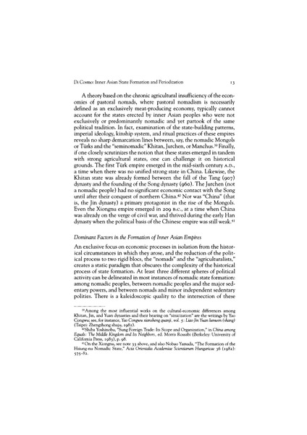

### identifier

3845840b-c0a4-4f01-ae01-3b88f74b14d7

### creator

Di Cosmo, Nicola

### type

Text

### coverage

Inner Asia

### description

The history of empires created by Inner Asian peoples bears direct relevance to the conceptualization of world history down to the early modern period, as their impact on surrounding civilizations resulted in long-lasting demographic, economic, and political changes. This essay explores the basic mechanisms of state formation in inner Asia and presents an argument for the periodization of Inner Asian history based on the incremental ability of Inner Asian empires to extract from outside sources the wealth necessary for the maintenance of political and military state apparatus. On this basis, the essay proposes a four-phase periodization, including ages of tribute empires (209 B.C.–A.D. 551), trade-tribute empires (551–907), dual administration empires (907-1259), and direct-taxation empires (1260–1796).

### publisher

Journal of World History

### source

<http://www.jstor.org/stable/20078749>

Nicola Di Cosmo, “State Formation and Periodization in Inner Asian History,” Journal of World History 10:1 (Spring 1999): 1-40.

### rights

Copyright

### subject

Inner Asia

history

### date

1999

### language

English

### format

application/pdf

### modified

2017-12-24 15:18:15

### public

False

### original filename

DiCosmo1999.pdf

### extent

4.8 MiB