Table: Gifts at a kolkhoz wedding, 1967

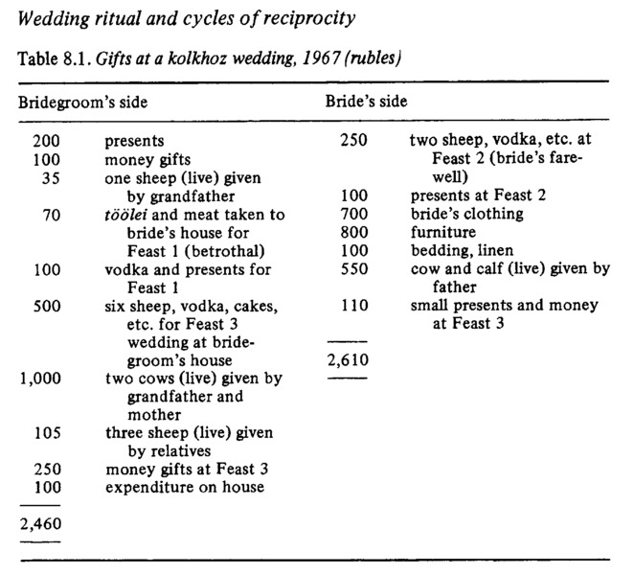

### identifier

3859c3bc-5b33-43be-a838-af29c7bd48f2

### creator

Humphrey, Caroline

### type

Image

### coverage

USSR

Buryatia

### description

### publisher

### source

Karl Marx Collective

### rights

### subject

### date

### language

### extent

67.8KiB

1914x2791 px

### contributor

### original filename

wedding-transactions.png

### relation

### format

image/png