mongon-taiga-film-transcript

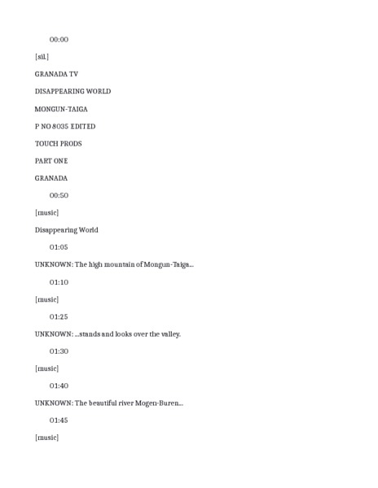

### identifier

3a3f3bc2-b626-4731-8f99-984cf4f4ee97

### creator

Humphrey, Caroline

Sheppard, John

### type

Text

### coverage

Tuva

USSR

### description

This is the full transcript for the film “Herders of the Mongun Taiga”.

### publisher

Royal Anthropological Institute

### source

<https://search.alexanderstreet.com/preview/work/2086388>

### rights

### subject

### date

1989

### language

English

### original filename

mongon-taiga-film-transcript.docx

### relation

70636433-042f-464d-91c0-d42291d1950f