Photographs of Dashbalbar sum, No. 43

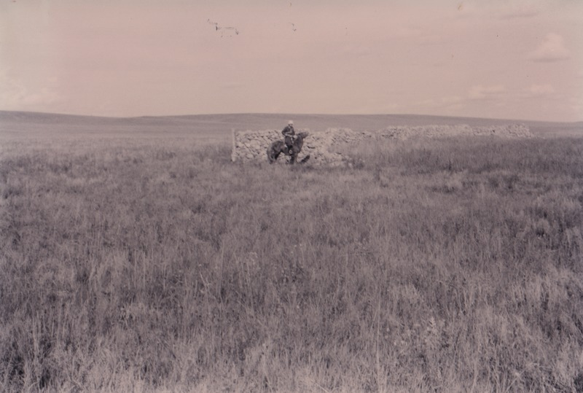

### identifier

3aa9ce04-dd46-43ce-8211-194b389a980f

### creator

Batbuyan B.

### type

Image

### coverage

Dashbalbar sum

Dornod aimag

Mongolia

### description

Disused stone enclosure, formerly used during the collectivized period.

### publisher

### source

Scanned from a photographic print held in the archives of the Mongolia and Inner Asia Studies Unit, University of Cambridge.

### rights

### subject

livestock enclosures

pastoral camps

### date

ca. 1994

### language

### format

image/png

### contributor

### original filename

bair-batbuyan-photos-43.png

### relation

### extent

1755x1182 px

2.8 MiB