Vitafit factory tour image - 2nfbuam5dkgvlm80ujqo30bhbm l

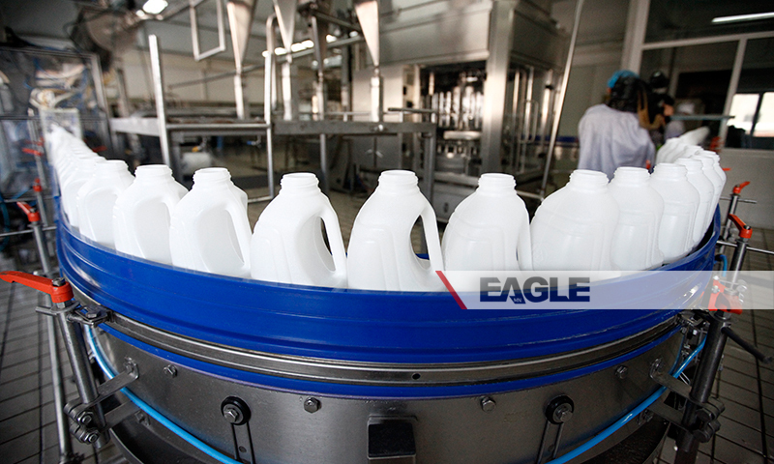

### identifier

3af76ef7-475c-40ab-95be-54a1f2a6dc34

### creator

### type

Image

### coverage

Mongolia

### description

Goyo yogurt factory tour image published by Eagle.mn.

### publisher

### source

### rights

### subject

Mongolia

dairy

nationalism

social media

### date

2014

### language

Vitafit factory tour image - Vitafit factory tour image - 2nfbuam5dkgvlm80ujqo30bhbm l

### format

image/jpeg

### original filename

2nfbuam5dkgvlm80ujqo30bhbm_l.jpg

### extent

369.7 KiB

800x480 px

### modified

2014-03-24 18:29:28