Map of Inner Asia (SRI)
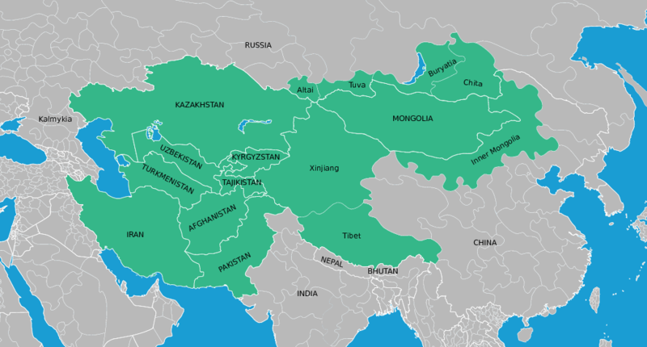

identifier
3bfd6968-94f4-4553-bcc6-a9c84e16a71e

creator
Thrift, Eric

type
Image

coverage
Inner Asia

description
Map of Inner Asia, locating the extent of the area studied by the Sinor Research Institute for Inner Asian Studies, located at Indiana University in the USA.

publisher
Culture and Development Research Centre

source
Based on <https://commons.wikimedia.org/wiki/File:Blank_Map_World_Secondary_Political_Divisions.svg> and <https://commons.wikimedia.org/wiki/File:BlankMap-World6.svg>

rights
Public domain

subject
Inner Asia
maps

date
2017

language
English

original filename
Inner-Asia-SRI.svg

extent
6.6 MiB

format
image/svg+xml

modified
2017-10-08 18:49:41

