Photograph from Govisumber, No. 09

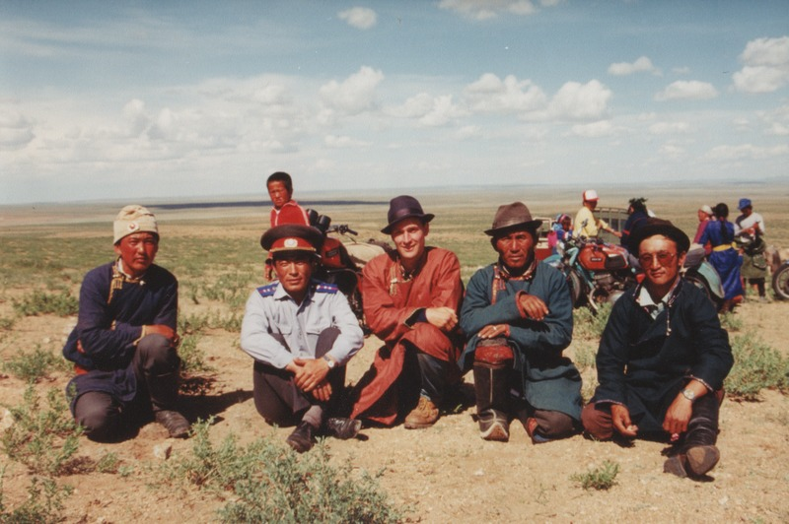

### identifier

3cd42c8c-24e4-4e6a-b0a3-6a36f59f5d08

### creator

Sneath, David

### type

Image

### coverage

Govisumber aimag

Mongolia

### description

### publisher

### source

scanned from a photographic print held in the archives of the Mongolia and Inner Asia Studies Unit, University of Cambridge

### rights

### subject

anthropologists in the field

research participants

### date

1995

### language

### format

image/png

### contributor

### original filename

sneath-govisumber_09.png

### relation

### extent

1776x1182 px

3.2MiB