David Sneath - photographs from Xingmeng, Yunnan - No. 25

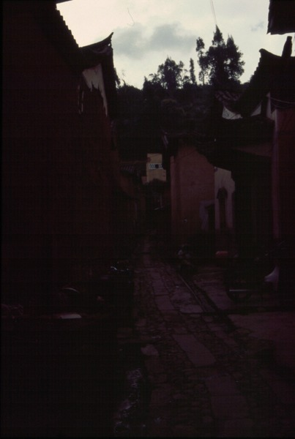

### identifier

3e292e16-d6b6-4dc3-90a6-d3d7f843fc9b

### creator

Sneath, David

### type

Image

### coverage

PRC

Yunnan

### description

### publisher

### source

Digitized from a 35mm slide provided by the author.

### rights

### subject

### date

1997

### language

### format

image/tiff

### contributor

### original filename

David Sneath - photographs from Xingmeng, Yunnan - No. 25.tif

### relation

### extent

42.6MiB

4704x3168 px

### public