Caroline Humphrey - Buryatia photos - No. 4-13

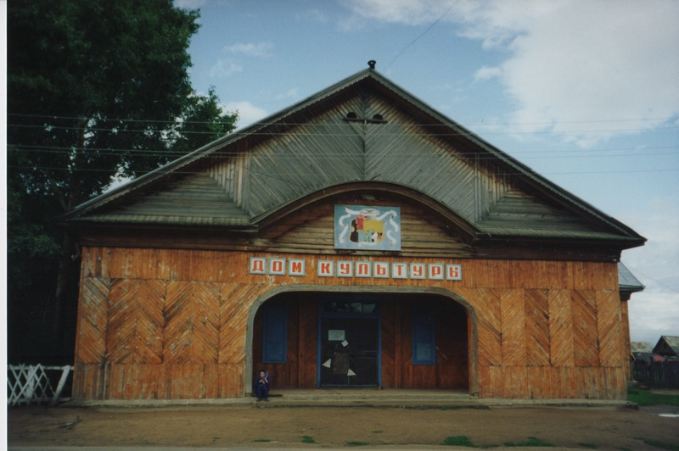

### identifier

3f2e576d-3934-4312-923d-02f4432cc428

### creator

Humphrey, Caroline

### type

Image

### coverage

Uro

Bayangol

Buryatia

USSR

### description

Culture centre.

### publisher

### source

Scanned from a print held in the archives of the Mongolia and Inner Asia Studies Unit, University of Cambridge.

### rights

### subject

### date

1993

### language

### contributor

### original filename

Humphrey-Buryatia-photos-4-13.png

### relation

### extent

3.3MiB

1799x1196 px

### format

image/png