Photograph from Inner Mongolia, No. 09

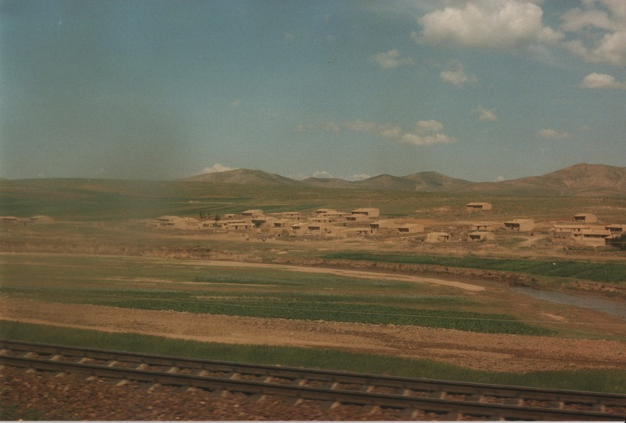

### identifier

40697baa-29d7-41d5-b55c-17c5ca7ea67a

### creator

Sneath, David

### type

Image

### coverage

Inner Mongolia

PRC

### description

View from the train window, Xilingol.

### publisher

### source

Scanned from a photographic print held in the archives of the Mongolia and Inner Asia Studies Unit, University of Cambridge.

### rights

### subject

steppe

### date

ca. 1988

### language

### original filename

sneath-inner-mongolia-1980s.png_09.png

### relation

### extent

3.0 MiB

1747x1182 px

### contributor

### format

image/png

### modified

2017-05-25 11:02:42