Camel coaxing ritual (video)

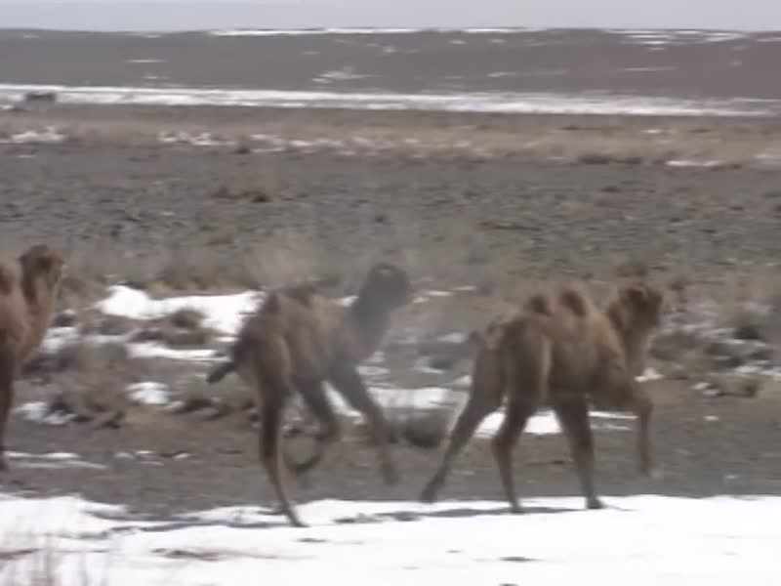

### identifier

441c0e73-e46b-4f93-aedc-8d82f419baf4

### creator

Boldbaatar, Yu.

### type

Moving Image

### coverage

Mongolia

### description

Short documentary video accompanying Mongolia’s nomination of the Camel coaxing ritual to the UNESCO List of Intangible Cultural Heritage in Need of Urgent Safeguarding, 2015.

Mongol herders have a coaxing ritual, which uses singing, music and chanting to help female camels accept newborns or adopted calves. A song is performed to the mother tied to a calf, using chants, gestures and music played on a fiddle or flute, to calm and unite them. Most herdswomen practise the ritual, transmitted during adolescence from parents or elders. It is considered important for maintaining community ties but under threat from rural-urban migration and greater use of modern transport.

### publisher

UNESCO

### source

<https://ich.unesco.org/en/USL/coaxing-ritual-for-camels-01061>

<https://www.youtube.com/watch?v=kHhseWLhKhY>

### rights

Copyright UNESCO

### subject

Camel coaxing

UNESCO

Rituals

Music

### date

2015

### language

English

### original filename

06282-EN.mp4

### extent

46.5 MiB

575.855000

### format

video/mp4

### modified

2018-03-26 10:10:39

### remote embed url

https://www.youtube.com/embed/kHhseWLhKhY