Respect and Power without Resistance: Investigations of Interpersonal Relations among the Deed Mongols

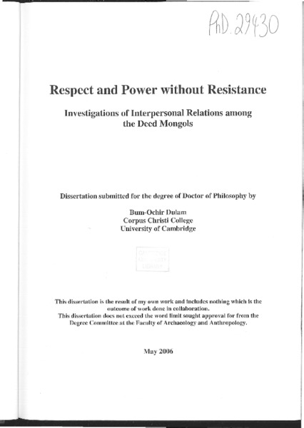

### identifier

446825fe-e35e-4537-a281-5fdb91f4b17b

### creator

Bum-Ochir, Dulam

### type

Text

### coverage

PRC

Qinghai

### description

Doctoral dissertation on Deed Mongols and respect for the State. ABSTRACT: The ethnographic part of this thesis concerns the Deed Mongols in Kok Nuur (Qinghai Sheng), a Tibetan province in the north west of China, where I conducted a twelve-month field study. Deed Mongols (population 80,000) reside in a unique cultural setting, amid three or four different cultures. Many share religious belief, lifestyle, and sometimes language with Tibetans, for instance the Deed Mongols in Henan Mongol Autonomous Xian in Huangnan Zhou. There are also some who have adopted the Chinese language and converted to Islam in the north of Haibei Zhou. However, Deed Mongols in Haixi, Hainan and Haibei zhous are pastoral nomads and still use classical Mongolian script and are familiar with Mongolian language and culture. My study focused on the latter group of people, one of the least studied communities of Inner Asia. This research is on a completely new topic, namely the coexistence of respect and power. I use the term respect with its widest range of meaning, as a socially constructed attitude that exalts the other person or his/her particular characteristics, achievements, talents, etc., or simply regarding someone as important and deserving of recognition. I analyse three main aspects of respect. One is the 'rationale of respect'. This brings up questions such as: What people mean when they respect? What is the meaning of respect? There are two kinds of ration ales of respect: one is the 'respect of common courtesy' and the other is the 'respect of hierarchy'. The second aspect is the question of 'expression of respect'. In the expression of respect sometimes it is more important to follow social regulations and to perform repeated, ritualized actions than to express personal intentions. This I call 'performative respect'. There are also cases where people can express their personal intention to respect, which I call 'non-performative respect'. In addition to these two classes of expression, there is also a third, which combines the other two. Following the same path I illustrate the third aspect of respect which is the question of the 'sincerity of respect'. Here, I classify respect into sincere and insincere, and explain when and why it is sincere or insincere. In this way the analysis of respect poses the question of whether any relationship is detached from respect. I have not been able to think of any type of relationship that does not bring up issues of respect or disrespect. Going beyond these considerations, I use the study of respect to approach the theory of power, something that allows us to see power from a completely new angle. Much of the literature on power suggests that the opposition of agents is essential to power, where one coerces and represses, the other responds with resistance and the dialogical relationship ends in conflict. In the discourse of power with respect that I propose, the powerful one supports and respects, but does not coerce and oppress and the powerless party in return respects and obeys, but does not resist. The overall outcome is not conflict but peace and harmony. I do not argue that human society can be completely peaceful, without any conflict and opposition at all. Instead, what I focus on is the attempt to achieve an ideal relationship based on such a 'formula of respect and power', and I illustrate the extent to which it becomes reality. I show that Deed Mongol villages rely more on the formula of 'respect and power' than that of 'resistance and power'.

### publisher

University of Cambridge

### source

https://doi.org/10.17863/CAM.16266

### rights

### subject

Deed Mongols

anthropology of the state

### date

2006-10-03

### language

English

### format

application/pdf

### modified

2017-05-29 12:12:48

### extent

102.6 MiB