David Sneath - photographs from Xingmeng, Yunnan - No. 03

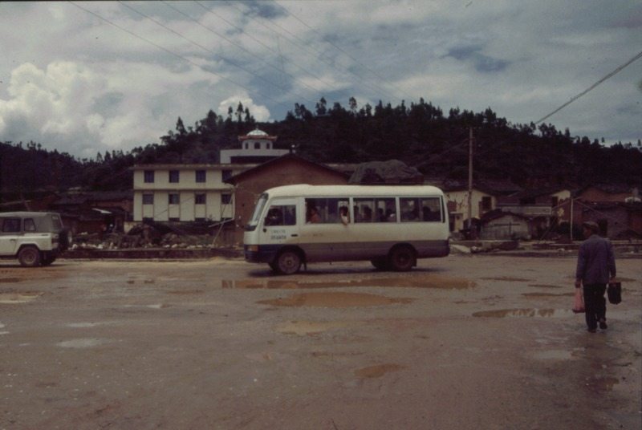

### identifier

44c708b5-9eac-423f-b95c-382c14deb719

### creator

Sneath, David

### type

Image

### coverage

PRC

Yunnan

### description

The Mongolian cultural centre and local government offices is

the most visible building in Xingmeng.

### publisher

### source

Digitized from a 35mm slide provided by the author.

### rights

### subject

### date

1997

### language

### format

image/tiff

### contributor

### original filename

David Sneath - photographs from Xingmeng, Yunnan - No. 03.tif

### relation

### extent

42.6MiB

4704x3168 px

### public