Photograph from Inner Mongolia, No. 03

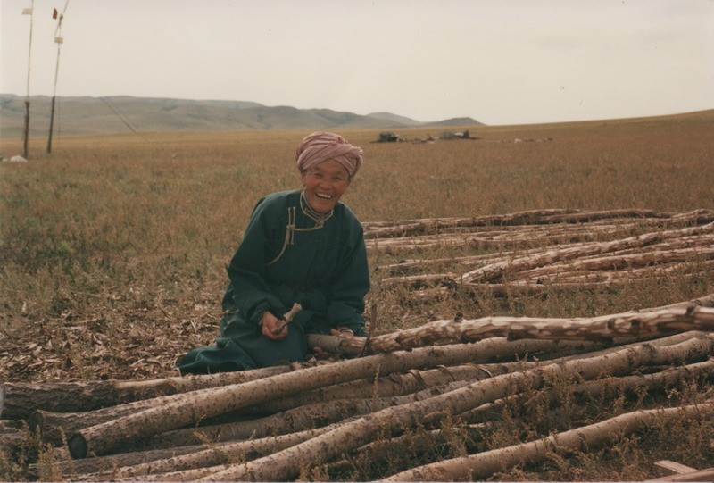

### identifier

45450b57-e3ec-4a5f-8f02-191fc4b1369a

### creator

Sneath, David

### type

Image

### coverage

Inner Mongolia

PRC

### description

Xilingol - Herder woman preparing wooden spars for extension of the family dwelling (baishin). The home is being constructed approximately 50--100 metres away; the wood logs will serve as a frame to be covered with clay daub.

### publisher

### source

Scanned from a photographic print held in the archives of the Mongolia and Inner Asia Studies Unit, University of Cambridge.

### rights

### subject

dwellings

### date

ca. 1988

### language

### original filename

sneath-inner-mongolia-1980s.png_03.png

### relation

### extent

3.0 MiB

1747x1182 px

### contributor

### format

image/png

### modified

2017-05-25 10:57:54