Yeröö breed rams at a well

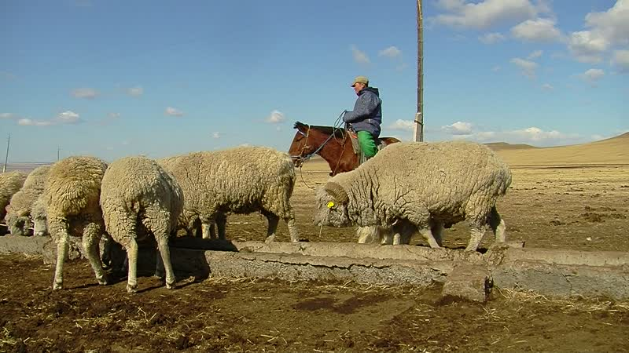

### identifier

454c3328-889e-4a25-b766-b313d6fd55a5

### creator

Thrift, Eric

### type

Moving Image

### coverage

Mongolia

Selenge aimag

Yeröö sum

### description

This video recording documents rams of the Yeröö breed being watered at a well. The rams are herded together by a single household, which distributes them to households participating in the Yeröö breeding program.

### publisher

### source

### rights

### subject

Pastoralism Videos

Yeroo Sheep-Rams

Watering Livestock

### date

2012-04-07

### language

### format

inode/directory

### modified

2018-01-17 20:15:05

### original filename

PastoralismVideos--2012-04-07--YerooSheep-Rams--WateringLivestock--Selenge-Yeroo.vclips

### table of contents

|  |  |  |
| --- | --- | --- |
| time | clip | description |
| 0:00:00 | 244 0264 01 |  |