Vitafit factory tour image - 208fr3e5dt03luv2htks38td1i l

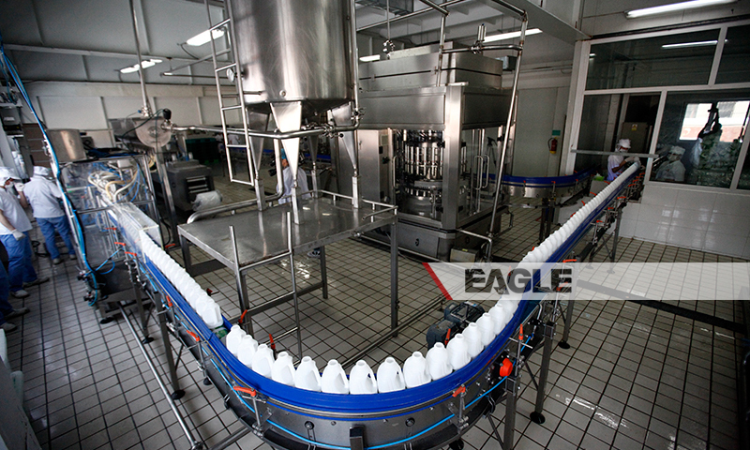

### identifier

49964372-6b03-4b89-8648-6fb86e7a024a

### creator

### type

Image

### coverage

Mongolia

### description

Goyo yogurt factory tour image published by Eagle.mn.

### publisher

### source

### rights

### subject

Mongolia

dairy

nationalism

social media

### date

2014

### language

Vitafit factory tour image - Vitafit factory tour image - 208fr3e5dt03luv2htks38td1i l

### format

image/jpeg

### original filename

208fr3e5dt03luv2htks38td1i_l.jpg

### extent

455.9 KiB

800x480 px

### modified

2014-03-24 18:29:10