Caroline Humphrey Mongolia Super8 film no. 22

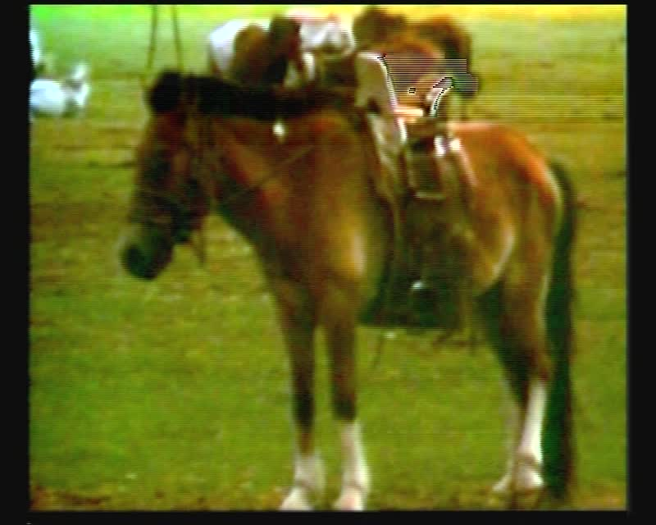

### identifier

4a3ae519-8e33-4528-94b7-0edd75bcf35c

### creator

Humphrey, Caroline

### type

Moving Image

### coverage

Mongolia

### description

Officials drinking airag; exterior of the herder camp; ox carts; horses; milking mares.

### publisher

MIASU

### source

Digitized from a VCR transfer tape held at the Mongolia and Inner Asia Studies Unit, University of Cambridge

### rights

Copyright Caroline Humphrey

### subject

airag

pastoral camps

### date

ca. 1970s

### language

None

### original filename

humphrey-super8-mongolia-22.mp4

### extent

871.2 MiB

209.835000

### format

video/mp4

### modified

2017-06-16 11:36:17

### alternate url

https://archive.org/embed/4a3ae519-8e33-4528-94b7-0edd75bcf35c