A Journey Across Central Asia, from Manchuria and Peking to Kashmir, over the Mustagh Pass

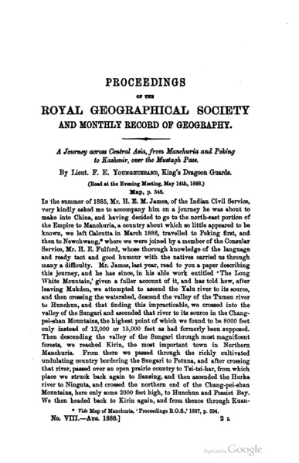

### identifier

4af653ca-6f58-4d41-8a59-0498529158d1

### creator

Younghusband, Francis

### type

Text

### coverage

### description

Lieutenant Colonel Sir Francis Edward Younghusband (1863–1942) was an explorer and military officer. He served as British commissioner to Tibet from 1902 to 1904 and as President of the Royal Geographical Society from 1919 to 1922. This paper addresses the geographical features of Central Asia: glaciers, horses, valleys, snow, towns, agricultural land, streams, deserts, glacial accumulation, ice

### publisher

Royal Geographical Society

### source

Proceedings of the Royal Geographical Society and Monthly Record of Geography, Vol. 10, No. 8 (Aug., 1888), pp. 485-518

### rights

Public domain

### subject

expeditions

geography

### date

1888

### language

English

### format

application/pdf

### modified

2017-10-09 13:46:36

### original filename

Younghusband1888.pdf

### extent

1.6 MiB