ITH-15-10.COM-10 EN

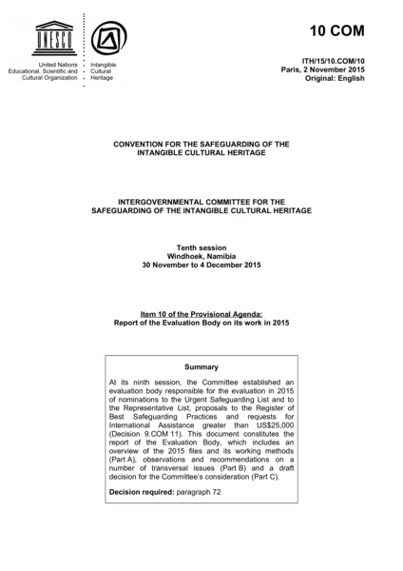

### identifier

4c933735-9df8-4953-8241-9b51eced6d4f

### creator

UNESCO Intergovernmental Committee for the Safeguarding of the Intangible Cultural Heritage

### type

Text

### coverage

Mongolia

### description

Decision to inscribe the “camel coaxing ritual” on the UNESCO List of Intangible Cultural Heritage in Need of Urgent Safeguarding.

### publisher

### source

<https://ich.unesco.org/en/decisions/10.COM/10.A.5>

### rights

### subject

### date

2015

### language

English

### original filename

ITH-15-10.COM-10_EN.doc

### extent

174.5 KiB

### format

application/msword

### modified

2016-02-24 14:42:39