Caroline Humphrey - Buryatia photos - No. 4-18

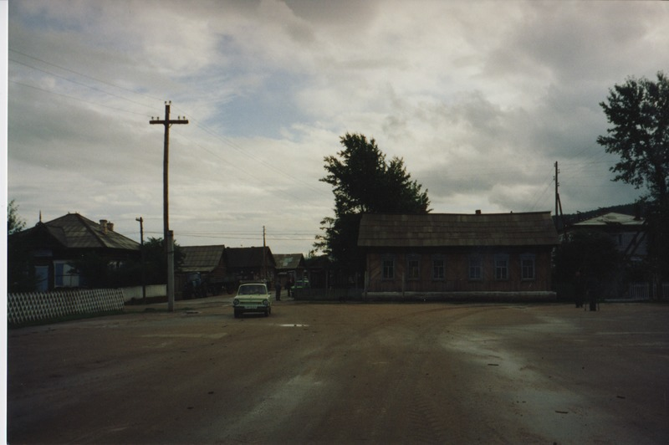

### identifier

4df85ff7-c0aa-4695-bdc8-4e3c8191061e

### creator

Humphrey, Caroline

### type

Image

### coverage

Uro

Bayangol

Buryatia

USSR

### description

### publisher

### source

Scanned from a print held in the archives of the Mongolia and Inner Asia Studies Unit, University of Cambridge.

### rights

### subject

### date

1993

### language

### extent

3.1MiB

1799x1196 px

### contributor

### original filename

Humphrey-Buryatia-photos-4-18.png

### relation

### format

image/png