Sample handwritten notes from ethnographic interview (Mongolian)
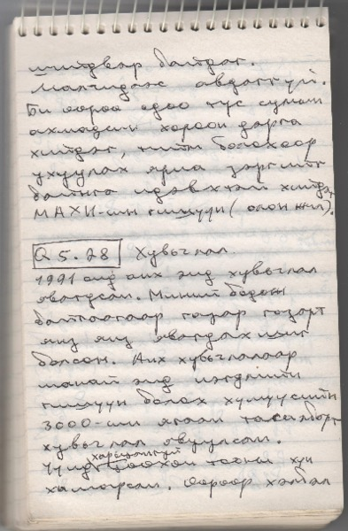

identifier
4ecba1b7-d092-47ba-b65d-5b1da1533dd7

creator
Telengid, B

type
Text

coverage
Mongolia

description

publisher

source
Scanned from an original document held in the archives of the Mongolia and Inner Asia Studies Unit, University of Cambridge.

rights

subject
ethnographic interviews
fieldnotes

date
ca. 1992

language
Mongolian

original filename
Telengid-interview-fieldnotes-mongolian-sample.pdf

relation

extent
1.5 MiB

contributor

format
application/pdf

modified
2017-05-29 12:12:48

