4021

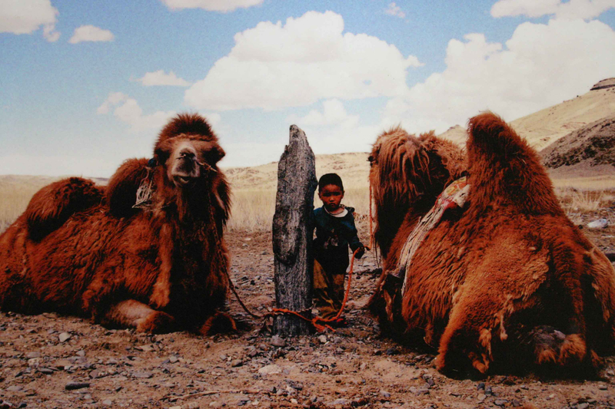

### identifier

4f48cee0-216b-4e11-bf78-e70712a22049

### creator

Boldbaatar, Yu.

### type

Image

### coverage

Mongolia

### description

Herder boy

### publisher

### source

https://ich.unesco.org/img/photo/src/4021.jpg

### rights

### subject

### date

2010

### language

### original filename

04021.jpg

### extent

1.5 MiB

3072x2048 px

### format

image/jpeg

### modified

2012-12-05 02:28:25