‘The Power of Two Homelands’: Musical continuity and change, the evocation of longing and an Altai Urianghai song

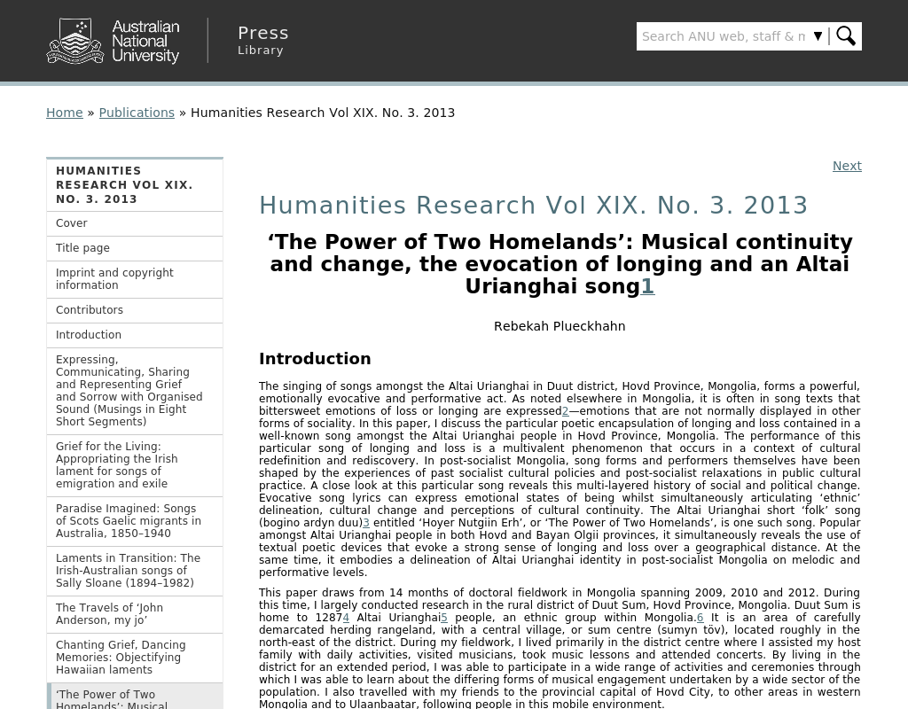

### identifier

4f6cd24f-53e0-4ca2-808a-dc7e2cfef17c

### creator

Plueckhahn, Rebekah

### type

Text

### coverage

Mongolia

Khovd aimag

### description

### publisher

### source

<http://press-files.anu.edu.au/downloads/press/p245301/html/ch07.xhtml>

### rights

### subject

ethnomosicology

Altain Uriankhai

### date

2017-05-23 11:50:43

### language

### original filename

Plueckhahn2013.url

### extent

69.0 B

### format

text/plain

### modified

2017-05-25 08:40:52