Photograph of Handgate, Xinjiang by Tsui Yen Hu, 1993, No. 51

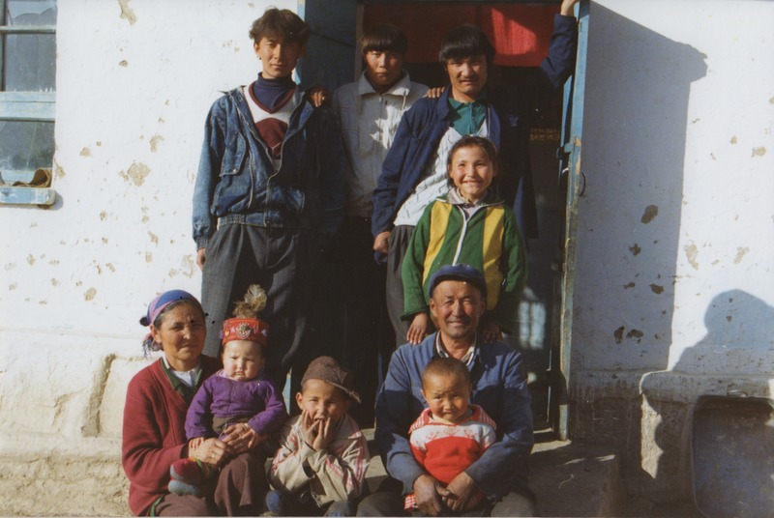

### identifier

4fef9cb3-4cbd-45ef-9e43-c23e91eac6db

### creator

Tsui Yen Hu

### type

Image

### coverage

Altai district

Handgate

PRC

Xinjiang

### description

HH 7, a 'worker' household, Handgate

### publisher

### source

Scanned from colour print held in the archives of the University of Cambridge MacArthur Project "Environmental and Cultural Conservation in Inner Asia", Mongolia and Inner Asia Studies Unit.

### rights

### subject

research participants

### date

1993-05-02

### language

### format

image/png

### contributor

### original filename

TsuiYenHu-Handgate-1993-51.png

### relation

### extent

1777x1191 px

3.3 MiB