Photographs of Dashbalbar sum, No. 30

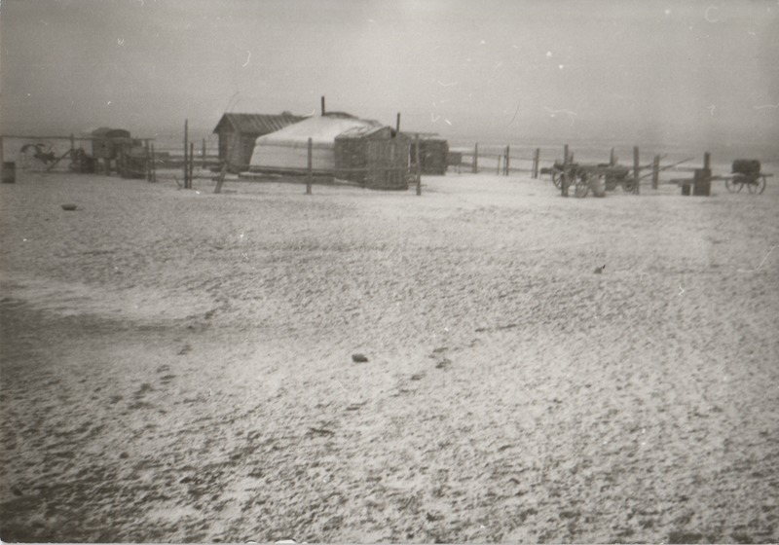

### identifier

504eeffc-87f7-4f17-bf1c-acfb270d8779

### creator

Batbuyan B.

### type

Image

### coverage

Dashbalbar sum

Dornod aimag

Mongolia

### description

Spring camp

### publisher

### source

Scanned from a photographic print held in the archives of the Mongolia and Inner Asia Studies Unit, University of Cambridge.

### rights

### subject

pastoral camps

### date

1993-03-21

### language

### format

image/png

### contributor

### original filename

bair-batbuyan-photos-30.png

### relation

### extent

1514x1060 px

2.4 MiB