Caroline Humphrey interview part 1

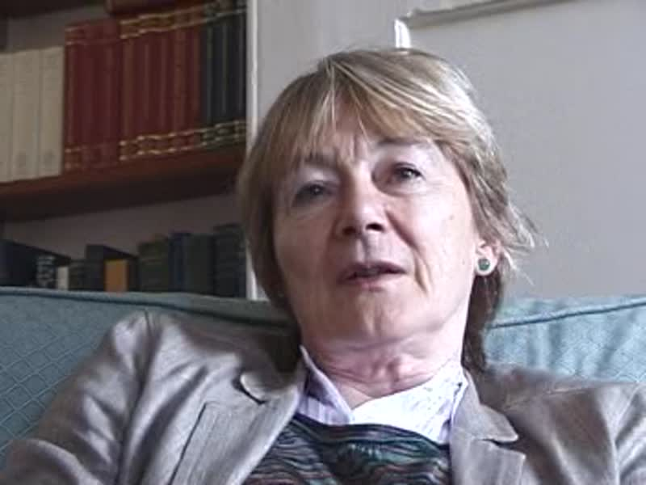

### identifier

51d7328b-8547-4e56-85d1-f1edb361c2f7

### creator

Humphrey, Caroline

### type

Moving Image

### coverage

Buryatia

Russia

USSR

### description

Caroline Humphrey interviewed by Alan Macfarlane on 5th August 2010

### publisher

### source

MIASU

### rights

### subject

### date

2017-05-25 10:46:14

### language

### extent

398.0MiB

3692.840000

### contributor

Macfarlane, Alan

### original filename

Caroline-Humphrey-interview-part-1.mp4

### relation

### format

video/mp4