Milking goats--Nomin and Oyunaa

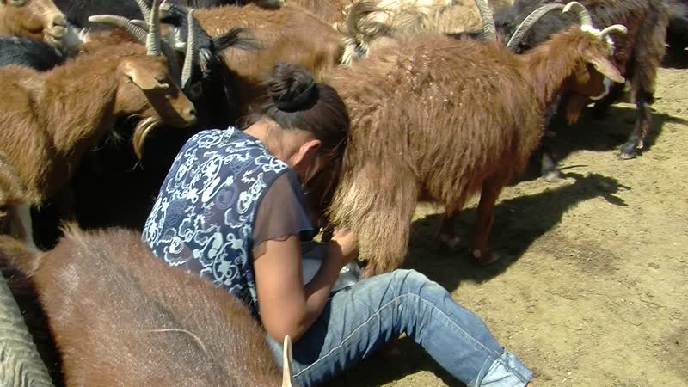

### identifier

576091fb-b5ed-4682-843d-edf94c9c4c92

### creator

Thrift, Eric

### type

Moving Image

### coverage

Mongolia

Dornogovi aimag

Erdene sum

### description

The recordings in this series show milking goats at Nomin and Oyunaa's place. The couple has recently moved some 40-50 kilometres away from their normal camp near Khamar Monastery, on otor in Erdene sum. We visited along with Oyunaa's parents from Khamar Monastery.

### publisher

### source

### rights

### subject

Pastoralism Videos

Milking Goats

Nomin-Oyunaa

### date

2012-06-29

### language

### format

inode/directory

### modified

2018-03-02 09:37:44

### original filename

PastoralismVideos--2012-06-29--MilkingGoats--Nomin-Oyunaa--Dornogovi-Erdene.vclips

### table of contents

|  |  |  |
| --- | --- | --- |
| time | clip | description |
| 0:00:00 | 300G0001 01 | Dolgor stitches a sack for draining curds (*aarts*) for her daughter. |
| 0:13:53 | 300G0001 02 | Dolgor continues to stitch a sack for draining *aarts*. |
| 0:27:47 | 300G0001 03 | Dolgor finishes stitching the sack for draining curds. Nar-Od stirs (*samrakh*) the fermented milk being heated in a pot on the stove. Dolgor tucks the new sack under the *uni* near the door. |
| 0:31:46 | 300G0002 01 | The outside of Nomin and Oyunaa's yurt, and their goats. |
| 0:32:21 | 300G0003 01 | Nomin begins to round up the goats for milking. He is joined by his wife and mother-in-law, who help to herd the goats into the pen. Dolgor and Oyunaa begin milking the goats. |
| 0:46:15 | 300G0003 02 | Dolgor and Oyunaa continue milking the goats, while Nomin handles the gate. |
| 1:00:09 | 300G0003 03 | Dolgor and Oyunaa continue milking the goats. Nomin chases after sheep and tries to catch sheep for shearing with a lariat. |
| 1:14:02 | 300G0003 04 | With the help of his nephew, Nomin catches a sheep and binds its legs. Dolgor and Oyunaa continue milking the goats. Nomin catches and binds a second sheep. He begins shearing. |
| 1:27:56 | 300G0003 05 | Nomin finishes shearing the sheep. His nephew takes the wool, rolls it up, and puts it away. Oyunaa and Dolgor continue milking the goats, as Nar-Od manages the gate. Nomin shears a second sheep. |
| 1:41:50 | 300G0003 06 | Nomin finishes shearing the second sheep. Dolgor and Oyunaa continue milking the goats for a while, then bring their full pails of milk back to the yurt. |
| 1:53:21 | 300G0004 01 | Inside the yurt, Dolgor and Oyunaa strain the goat's milk through cheesecloths into aluminum pails and empty soft drink bottles. Oyunaa hangs up the curd straining sack that her mother stitched for her earlier in the morning, with a container underneath to catch the whey. She takes the pot of boiled fermented milk from the stove and places it next to the straining sack, then begins to ladle the milk into the sack. |
| 1:59:51 | 300G0004 02 | Oyunaa finishes ladling the milk into the straining sack, then places the pot back on top of the stove. |