Photograph of Handgate, Xinjiang by Tsui Yen Hu, 1993, No. 28

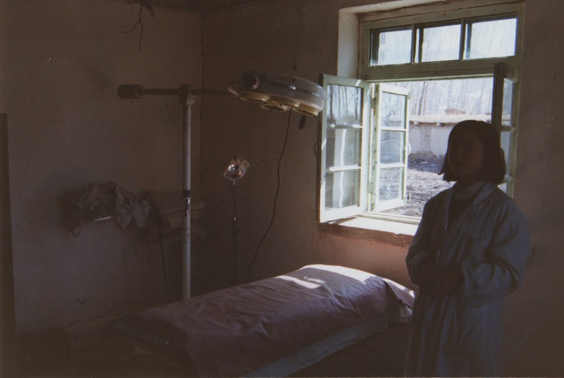

### identifier

597b1d70-f839-4e64-9df6-ae9178549a63

### creator

Tsui Yen Hu

### type

Image

### coverage

Altai district

Handgate

PRC

Xinjiang

### description

Surgical operating room, Handgate Hospital

### publisher

### source

Scanned from colour print held in the archives of the University of Cambridge MacArthur Project "Environmental and Cultural Conservation in Inner Asia", Mongolia and Inner Asia Studies Unit.

### rights

### subject

medicine

### date

1993-04-18

### language

### format

image/png

### contributor

### original filename

TsuiYenHu-Handgate-1993-28.png

### relation

### extent

1777x1191 px

3.2 MiB