Country research paper: Pastoral movement patterns of Mongolian herders and their socio-economic aspects

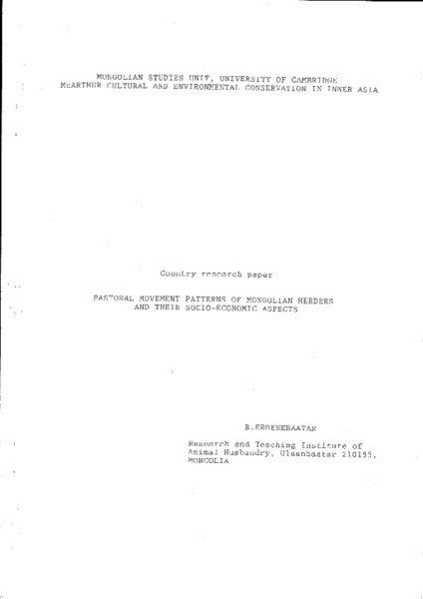

### identifier

5998ff63-9a81-4d0b-ab73-125e9735f10e

### creator

Erdenebaatar, B

### type

Text

### coverage

Mongolia

Uvs aimag

Turgen sum

Sagil sum

### description

Report on ethnographic fieldwork and a study of historical documents concerning mobility patterns among herders in Mongolia. Chapter three contrasts mobility patterns in the pre-collective, collective, and post-collective periods.

### publisher

### source

Scanned from an original document held in the archives of the Mongolia and Inner Asia Studies Unit, University of Cambridge.

### rights

### subject

mobility patterns

reports

### date

ca. 1992

### language

English

### original filename

erdenebaatar-household-mobility-report.pdf

### relation

### extent

16.5 MiB

### contributor

### format

application/pdf

### modified

2017-05-29 12:12:48