Vitafit factory tour image - 2i8rtsb64oee3627plepiobr61 l

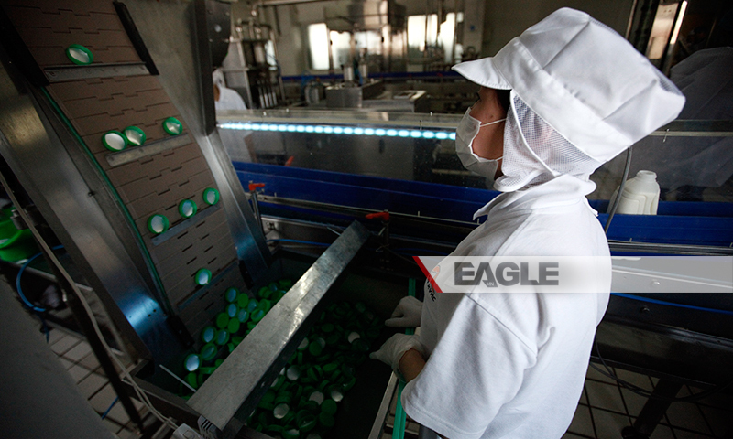

### identifier

59f40e7f-2254-4d61-bfe2-2de1cf3938da

### creator

### type

Image

### coverage

Mongolia

### description

Goyo yogurt factory tour image published by Eagle.mn.

### publisher

### source

### rights

### subject

Mongolia

dairy

nationalism

social media

### date

2014

### language

Vitafit factory tour image - Vitafit factory tour image - 2i8rtsb64oee3627plepiobr61 l

### format

image/jpeg

### original filename

2i8rtsb64oee3627plepiobr61_l.jpg

### extent

340.7 KiB

800x480 px

### modified

2014-03-24 18:29:06