Photographs of Dashbalbar sum, No. 46

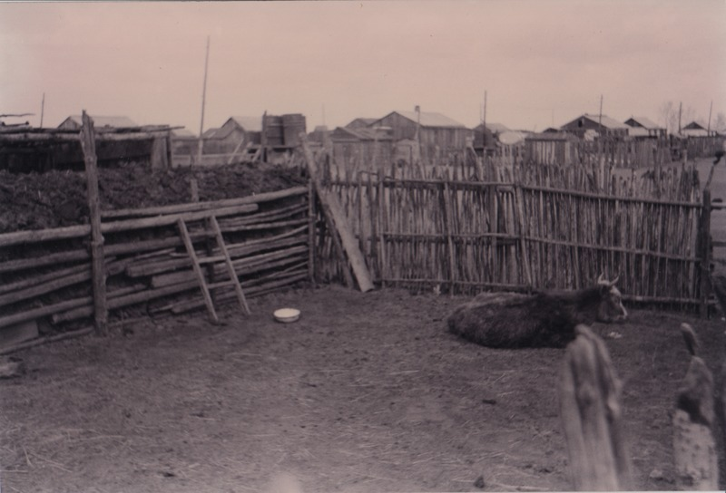

### identifier

5b0bfa9e-d790-4835-b696-15b22c2b25f3

### creator

Batbuyan B.

### type

Image

### coverage

Dashbalbar sum

Dornod aimag

Mongolia

### description

In a back yard (*khashaa*) in Dashbalbar sum centre.

### publisher

### source

Scanned from a photographic print held in the archives of the Mongolia and Inner Asia Studies Unit, University of Cambridge.

### rights

### subject

settlements

town residences

### date

ca. 1997

### language

### format

image/png

### contributor

### original filename

bair-batbuyan-photos-46.png

### relation

### extent

1753x1191 px

2.8 MiB