Photographs of Dashbalbar sum, No. 45

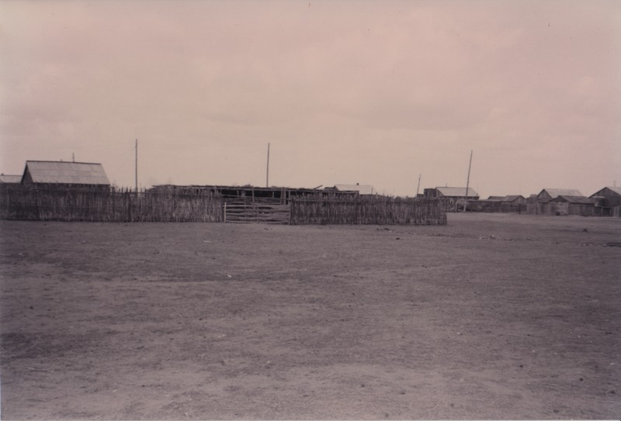

### identifier

5bd91653-ae76-4a93-be71-c20748d22cb4

### creator

Batbuyan B.

### type

Image

### coverage

Dashbalbar sum

Dornod aimag

Mongolia

### description

Dashbalbar sum centre, fencing made of thin wood poles

### publisher

### source

Scanned from a photographic print held in the archives of the Mongolia and Inner Asia Studies Unit, University of Cambridge.

### rights

### subject

settlements

### date

ca. 1996

### language

### format

image/png

### contributor

### original filename

bair-batbuyan-photos-45.png

### relation

### extent

1756x1191 px

2.7 MiB