Caroline Humphrey Mongolia Super8 film no. 16

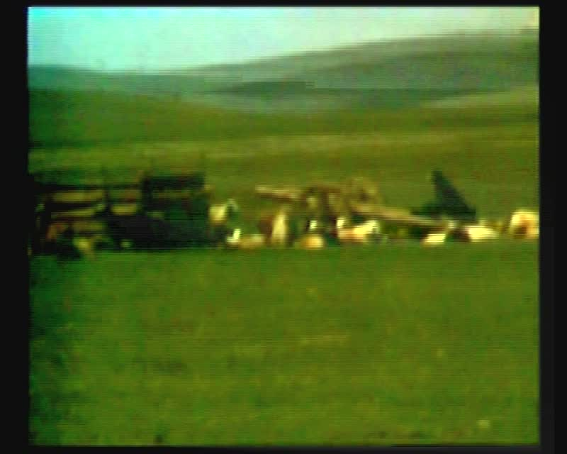

### identifier

5bed8689-5491-4acc-825e-6af7cd4d7b9d

### creator

Humphrey, Caroline

### type

Moving Image

### coverage

Mongolia

### description

Milking mares; view of the herders' camp; herder bringing milk into the ger.

### publisher

MIASU

### source

Digitized from a VCR transfer tape held at the Mongolia and Inner Asia Studies Unit, University of Cambridge

### rights

Copyright Caroline Humphrey

### subject

milking

pastoral camps

### date

ca. 1970s

### language

None

### original filename

humphrey-super8-mongolia-16.mp4

### extent

886.4 MiB

216.000000

### format

video/mp4

### modified

2017-06-16 10:57:54

### alternate url

https://archive.org/embed/5bed8689-5491-4acc-825e-6af7cd4d7b9d