9410

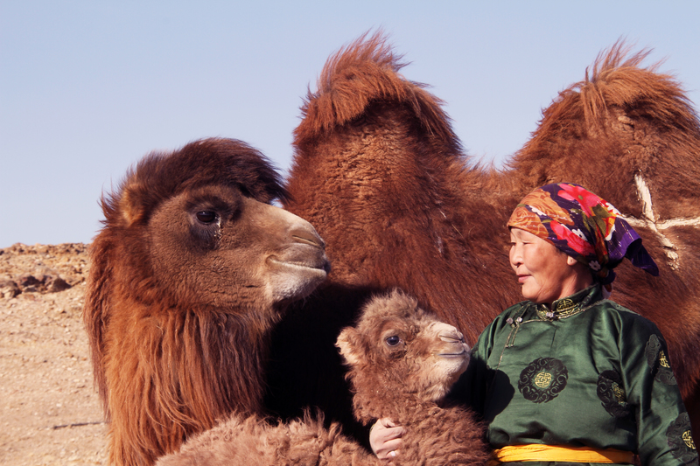

### identifier

5c806e04-d20a-4105-8d33-6c43e29f891a

### creator

Boldbaatar, Yu.

### type

Image

### coverage

Mongolia

Ömnögovi aimag

Mandal-Ovoo sum

### description

The coaxing ritual for baby camels - 4 Coaxed mare-camel and orphan calf

### publisher

### source

https://ich.unesco.org/img/photo/src/09410.jpg

### rights

### subject

### date

2013

### language

### original filename

09410.jpg

### extent

9.2 MiB

5184x3456 px

### format

image/jpeg

### modified

2016-02-24 14:46:52