LamaInterviewAndBuddhistMonastery

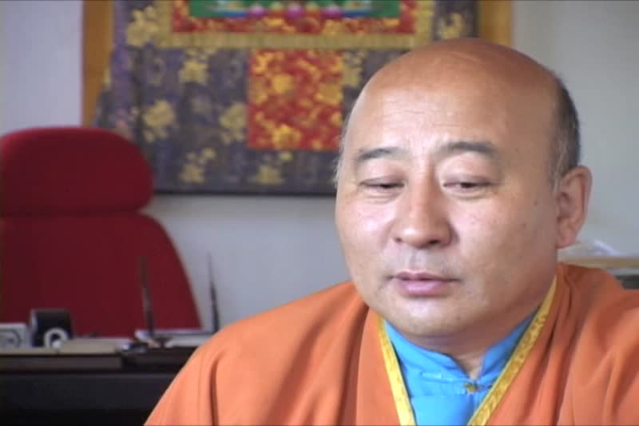

### identifier

5ca211bb-8e5a-4fa9-9cc6-16ddb77589e8

### creator

Penn Museum

### type

Moving Image

### coverage

Mongolia

Ulaanbaatar

### description

Buddhist Monastery. Exterior shot; monks accepting money. Lama Interview.

### publisher

University of Pennsylvania Museum of Archaeology and Anthropology Films

### source

<https://archive.org/details/UPMAA_films>

### rights

All rights are reserved by the University of Pennsylvania Museum of Archaeology and Anthropology (Penn Museum). Any use of the footage in productions is forbidden unless rights have been secured by contacting the Penn Museum Archives at 215-898-8304, or email photos@pennmuseum.org. This film and all of the films in the Penn Museum collection are copyrighted by the Penn Museum, and are not in the public domain.

### subject

### date

2011-06-24 13:35:15

### language

Mongolian

### original filename

LamaInterviewAndBuddhistMonastery.mov

### extent

1.4 GiB

2349.781667

### format

video/quicktime

### modified

2011-06-24 05:35:14

### remote embed url

https://archive.org/embed/V-450-18

### public

FALSE