Vitafit factory tour image - 6qaeth1sn02fsbiv9obn3miqrb l

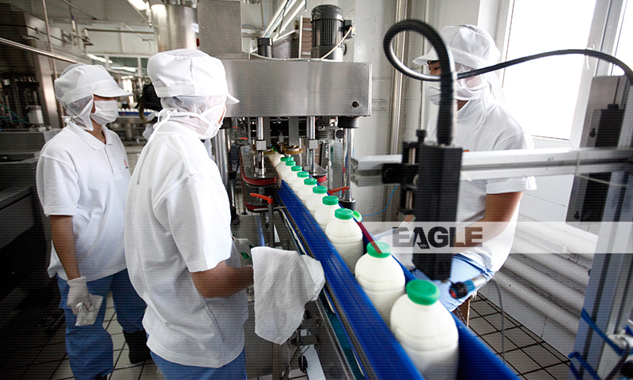

### identifier

5e5c54af-db44-4bf8-aeec-f1a467680911

### creator

### type

Image

### coverage

Mongolia

### description

Goyo yogurt factory tour image published by Eagle.mn.

### publisher

### source

### rights

### subject

Mongolia

dairy

nationalism

social media

### date

2014

### language

Vitafit factory tour image - Vitafit factory tour image - 6qaeth1sn02fsbiv9obn3miqrb l

### format

image/jpeg

### original filename

6qaeth1sn02fsbiv9obn3miqrb_l.jpg

### extent

383.2 KiB

800x480 px

### modified

2014-03-24 18:29:26