Map of household mobility in Uvs

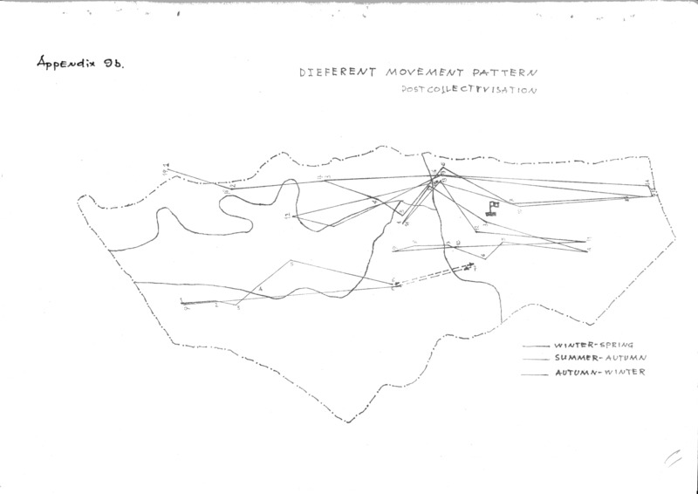

### identifier

62339f15-86c2-4060-a4be-b220cae7a200

### creator

Erdenebaatar, B

### type

Image

### coverage

Mongolia

Uvs aimag

Turgen sum

Sagil sum

### description

Taken from Erdenebaatar's report on mobility patterns (Appendix 9b). This map contrasts the different mobility strategies of post-collective households

### publisher

### source

Scanned from an original document held in the archives of the Mongolia and Inner Asia Studies Unit, University of Cambridge.

### rights

### subject

mobility patterns

maps

### date

ca. 1992

### language

### original filename

macarthur-erdenebaatar-household-moves-map_2.png

### relation

### extent

75.2 KiB

3507x2480 px

### contributor

### format

image/png

### modified

2017-05-25 10:40:52